
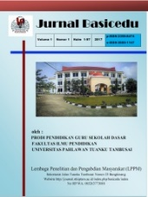
JURNAL BASICEDU
Volume x Nomor x Bulan x Tahun x Halaman xx
Research & Learning in Elementary Education
https://jbasic.org/index.php/basicedu

THE EFFECT OF DISCOVERY LEARNING MODEL WITH AUDIO VISUAL MEDIA ON STUDENT LEARNING OUTCOMES

Yusmawati¹, Cecep Anwar Hadi Firdos Santosa², Suroyo³
Pascasarjana Universitas Terbuka, Universitas Sultan Ageng Tirtayasa, Universitas Terbuka
Yusmawati80@gmail.com, cecepanwar@untirta.ac.id, suroyo@ecampus.ut.ac.id

Abstrak
Tujuan penelitian ini adalah untuk mengetahui pengaruh model pembelajaran discovery learning dengan media audio visual dan terhadap hasil belajar siswa, Serta mengkaji perbedaan hasil belajar antara siswa dengan self-confidence tinggi dibandingkan dengan siswa yang memiliki self- confidence rendah. Metode yang digunakan dalam penelitian ini adalah quasi eksperimen yang melibatkan siswa kelas 5 Sekolah Dasar pada mata pelajaran Ilmu Pengetahuan Alam (IPA). Hasil penelitian menunjukan bahwa pembelajaran model discovery learning dengan audio visual dan games memiliki perbedaan yang signifikan terhadap hasil belajar IPA Secara keseluruhan. Selanjutnya terdapat perbedaan hasil belajar IPA siswa antara siswa dengan self-confidence tinggi dengan siswa yang memiliki self-confidence rendah.
Kata Kunci: Discovery Learning, self-confidence, Hasil Belajar.

Abstract
The purpose of this study was to determine the effect of discovery learning models with audio-visual media on student learning outcomes, and to examine differences in learning outcomes between students with high self-confidence compared to students with low self-confidence. The method used in this study is a quasi-experimental involving 5th grade elementary school students in the Natural Sciences subject. The results showed that the discovery learning model with audio-visual and games had a significant difference in overall science learning outcomes. There is a difference in student science learning outcomes between students with high self-confidence and students with low self-confidence.
Keywords: Discovery Learning, self-confidence, learning outcomes.

Copyright (c) 2021 Nama Penulis¹, Nama Penulis² dst

Corresponding author :
Email : alkhair2505@gmail.com ISSN 2580-3735 (Media Cetak)
HP : +6285267471511 ISSN 2580-1147 (Media Online)

Received xx Bulan 2021, Accepted xx Bulan 2021, Published xx Bulan 2021

INTRODUCTION
To achieve the goals of national education, teachers play a major role in realizing students who have faith, character, intelligence, noble character for themselves, society, nation and state. Learning design that is able to increase students' attention and the meaning of the concept is to involve technology and information media. As in Regulation of the Minister of National Education No. 78 of 2009 states that the learning process applies a learning approach based on information and communication technology, active, creative, fun and contextual (Departemen Pendidikan Nasional 2007).
One of the subjects taught at primary school level are subjects of Natural Sciences (IPA), with their science teaching is expected that learners are able to master knowledge, especially about nature, whether in the form of facts, concepts, principles, and discovery, through direct experience or not directly to develop the potential of students (Butar-butar and Mauli 2017) (Kaban et al. 2020).
Efforts that can be made to achieve learning objectives are to use various learning strategies, one of the models that can be applied is the discovery learning model, this learning model can be done with the help of audio-visual learning media. Researchers also want to know whether this discovery learning strategy affects student learning outcomes when using games. Then the student learning outcomes is done by comparing the specs back learner who has high self-confidence and low self-confidence is low.
The results of the initial observations showed that the students' scores were below the standard KKM scores, namely the average grade 5A science learning outcomes were 63.00. Class 5B average 62.41. One of the contributing factors is that teachers only use simple learning media. The number of student scores below the KKM can be caused by several factors, including teachers who are not precise in implementing learning strategies, other factors, namely teachers only use simple learning media, namely blackboards and books, so students only memorize conceptually but they do not use reasoning power to understand deep learning. After referring to the problems that occurred, the purpose of this study is to examine the differences in student science learning outcomes between students who use the audio-visual-assisted discovery learning model and those who use the games -assisted discovery learning model, to examine the differences in learning outcomes between students with high self-confidence compared to students. who have low self-confidence, (Aisyiah, Taufina, and Montessori 2020)(Fitri, Adnan, and Irdamurni 2020)
Learning outcomes are all abilities possessed by students, both affective, cognitive and psychomotor after he received his learning experience (Sudjana 2015) (Sudjana and Rivai 2013). Discovery learning is the rationale of a character named Bruner who has the idea that students must be active in learning activities in class. Bruner views that concept formation is an activity of categorizing and placing examples into the classroom using certain criteria (Nurhadiyati, Rusdinal, and Fitria 2020).
According to (Inde, Kaleka, and Ilyas 2020) Lauter (2002) self-confidence is an attitude of belief in one's abilities and confidence in himself, so that in his behavior he is able to control himself well, always thinks positively, is not easily anxious, assumes self is free to do something in accordance with the aims and objectives and is responsible for his behavior, polite in communicating with others, has the desire to achieve and is able to understand his own strengths and weaknesses. Lauster describes that people who have self-confidence have the characteristics of selflessness (tolerance), do not need encouragement from others, are optimistic and feelhappy.

METHOD
This research was designed in the form of a quasi-experimental or quasi-experimental. This design was chosen because it is considered not to have strict restrictions on randomization, and at the same time it can control validity threats.
The population of this study were students from SDN. Bujanggadung, this school is used as the population because the elementary school is a stable school in the Grogol sub-district, Cilegon Banten and has been accredited A, The sampling technique used in this research is cluster sampling. This technique uses a sample based on a defined population, namely SDN. Bujanggadung, Grogol District, Cilegon City. The experimental class 1 was used in class 5A with 35 students, while the experimental class 2 in class 5B with 35 students. Non -self-confidence test was used for sampling, which had the highest and lowest ranges. For the highest self-confidence used 27% of the total number of students and 27% of low self-confidence, so it can be determined a sample of 10 students for high self-confidence and 10 students with low self-confidence with discovery learning treatment with audio-visual media. in the experimental class 1 and games in the experimental class 2.
data collection was done through direct observation at SDN. Bujanggadung especially class VA and VB, the data used from all variables are learning outcomes and questionnaires. Data in the form of learning outcomes in the form of a multiple-choice test, whereas the data questionnaire consisted of self-confidence and high self-confidence is low.
The research procedure begins with processing the results of the questionnaire. The results of the questionnaire are processed by making a classification table of students in the experimental class 1 and experimental class 2 with high and low self-confidence. This is done to group the results of student learning tests, then make a table of student test scores in the experimental class 1 and experimental class 2. Conduct a normality test to determine the normality of the post-test score data. Test the homogeneity of variance test scores. To test the difference in interactions between discovery learning learning strategies using videos and games, with self-confidence (high, low) on student learning outcomes by statistical testing using statistical software, namely analysis of variance (ANOVA).

RESULTS AND DISCUSSION
1. Description of students' science learning outcomes
The results of the science learning data were obtained from multiple choice test questions consisting of 10 questions. Collecting data from experimental class 1 by applying discovery learning with audio-visual and experimental class 2 using discovery learning with games. Calculations with the help of SPSS 22.0 with the following results:

Table 1: Descriptive Statistics of the Average Score of Learning Media Usage

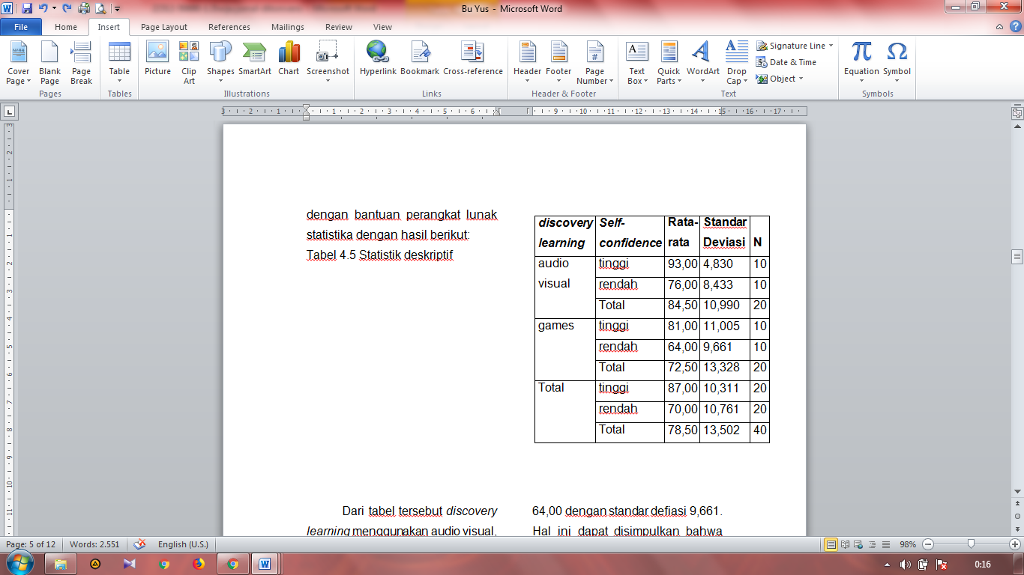

From table 1, discovery learning uses audio-visual, with high self-confidence with a mean of 93.00 with a standard deviation of 4.830, while discovery learning uses audio-visual with low self-confidence with an average of 76.00 and a standard deviation of 8.433. For discovery learning using games for students who have high self-confidence of 81.00 with a standard deviation of 11.005, while the experimental class using discovery learning using games with low self-confidence has an average of 64.00 with a standard deviation of 9.661. It can be concluded that there are differences in students' science learning outcomes in experimental class 1 and experiment 2, where experimental class 1 uses discovery learning with audio-visual and experimental class 2 uses games.
Table 1 also shows the results that the highest average is in the experimental class 1 using discovery learning audio-visual which is 93.00 while the lowest average is in the experimental class 2 using discovery learning games of 64.00. Overall, the average score obtained by the experimental class 1 or group of students with audio-visual-assisted discovery learning was 84.50 with a standard deviation of 10.99, with the histogram formation as follows:

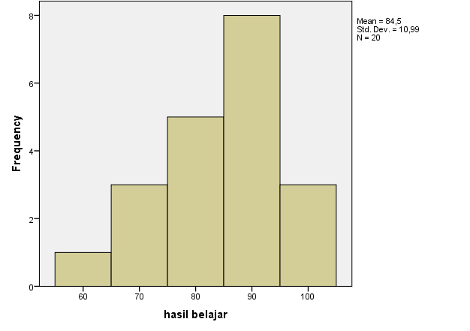

Figure 1: Histogram of science learning outcomes in the experimental class 1

While the experimental class 2, namely the group of students with the help of media games got an average score of 72.50 with a standard deviation of 13,328. The histogram of the experimental class 2 is described as follows:
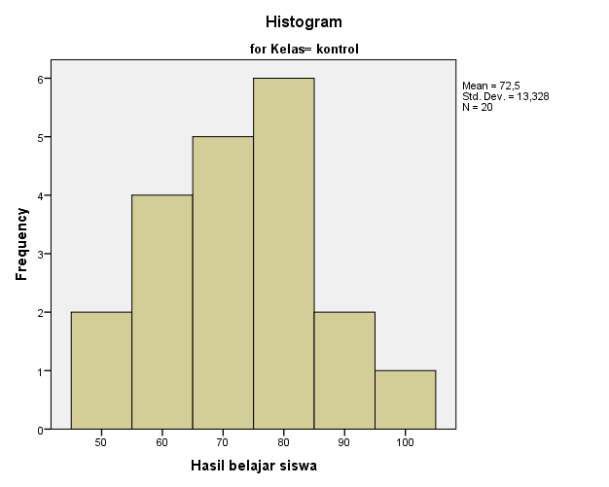

Figure 2: Histogram of students' science learning outcomes in experimental class 2.

To test the hypothesis in this study, the 2-way Anova test was used 2x2 (Two-way Anova). Based on the results of the two-way ANOVA hypothesis test with the help of software applications, it can be seen in the following table:

Table 2: Two-way ANOVA Test
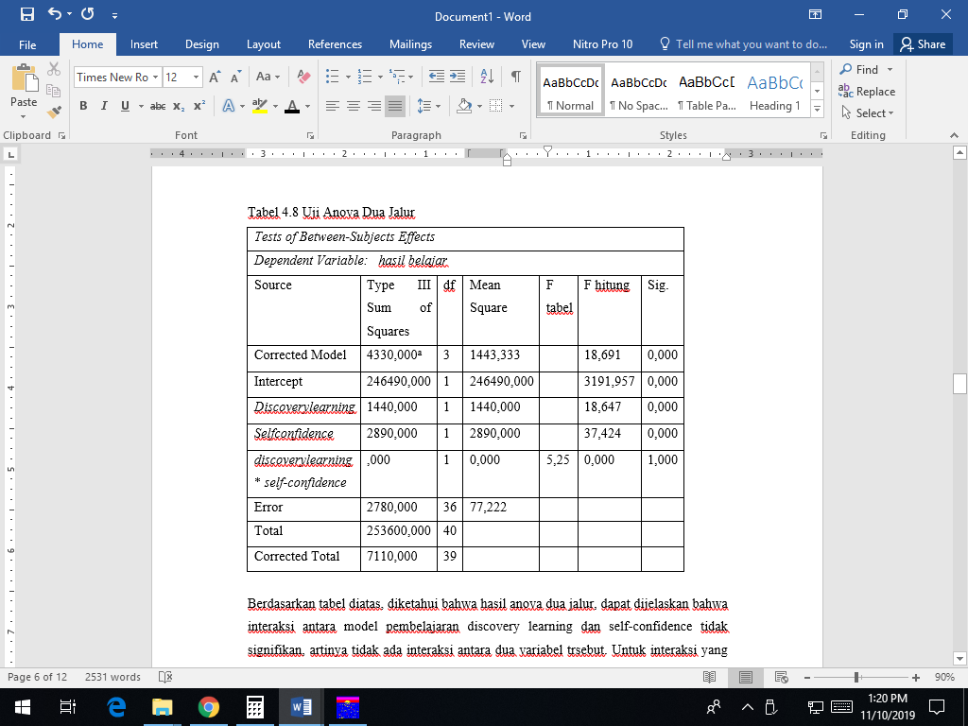
Based on table 2 above, it is known that the results of the two-way ANOVA can be explained that the interaction between discovery learning and self-confidence is not significant, meaning that there is no interaction between the two variables. For the interaction used is calculated F, before looking for the calculated F value, first look for the F table, by calculating the value of DF 1 = 3-1 = 2 and the value of DF 2 = 40-3-1 = 36. Then look for the F table with probability 0 0.05, the F table value is 3.26.
Based on table 2 there is no interaction between discovery learning learning models and self-confidence, but it can be explained from the picture above why audio visuals are above games, because the use of audio visuals is more effective and the class is more conducive than using games, this happens because when students playing games they become noisy and don't want to stop playing and act as if it's just a game, there is no learning element, while the use of audio-visual experimental class 1 is more focused on learning and observing what is displayed on the screen. For more details, the researcher conducted a simple further test of the effect.

Pairwise Comparisons
Dependent Variable: Learning Outcomes
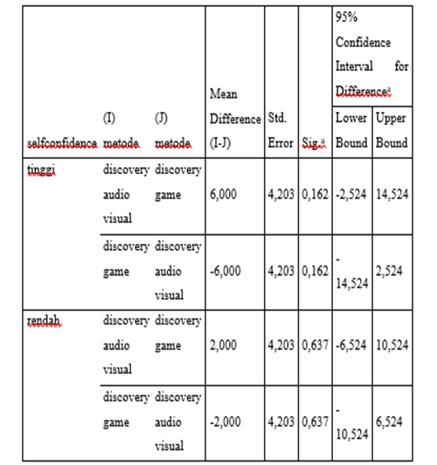

Figure 3: simple discovery learning and self-confidence effects

From Figure 3 above, the effect for high self-confidence with the discovery learning model assisted by audio-visual and gams is 0.162, this value is > from 0.05, for low self-confidence with the discovery learning model assisted by audio-visual and games the significance value is 0.637. the value is > from 0.05 so it is not significant.

1. Differences in students' science learning outcomes with discovery learning models with audio-visual and games.
Based on the results of the calculations described previously, it can be seen that the average value of discovery learning with audio-visual is higher at 84.50 while the average value of discovery learning with games is lower with a value of 72.5.
There is no interaction between the use of discovery learning learning models and self-confidence. From the results of the tests carried out, there is no interaction between the use of the discovery learning model and self-confidence. This happens after it is known that the results of the test conducted, the f table value between the discovery learning model and self-confidence is smaller than the calculated f, i.e. 0.00 < 5.25. So it can be stated that there is no interaction between the discovery learning model and self-confidence on student learning outcomes.

2. Differences in learning outcomes of students with high self-confidence compared to students with low self-confidence.
Based on the analysis of learning outcomes there is a difference between self-confidence and high self-confidence is low, because of the attitude and character of students is also formed and influenced by the level of confidence (self-confidence) students themselves.
Student learning outcomes in this study were grouped into two large groups of students according to their level of self-confidence. By providing discovery learning and discriminatory learning models in the use of instructional media, this research can show differences in the value of learning outcomes from the two groups. In general, it is often easy to see that students with high levels of self-confidence will always get better learning outcomes than students with low levels of self-confidence. This is reinforced by the results of the questionnaire distributed, in students with high self-confident scores on statements no. 20 and 21 are high, while for students with low self-confidence statements on no. 21 and 22 are low. In the questionnaire statement contained in Appendix 3, students tend to have difficulty in understanding the questions and how to solve them. Then students also feel that they do not have sufficient intelligence so that a lack of confidence appears in students who are weak in learning. For students with high self-confidence, there are differences in student science learning outcomes, between those using audio-visual-assisted discovery learning, compared to games -assisted discovery learning.
In accordance with the results of tests conducted by students who have high self-confidence using the discovery learning model assisted by audio visuals, the average value obtained is 93 while students who have high self-confidence by using the discovery learning model assisted by games the average value obtained 81, it can be concluded that there are differences in student science learning outcomes, between those using audio-visual-assisted discovery learning, compared to games -assisted discovery learning .
For students with low self-confidence, there are differences in student science learning outcomes between those using discovery learning assisted by games, compared to discovery learning assisted by audio-visuals. This happens because the results of tests conducted by students who have low self-confidence using the audio-visual-assisted discovery learning model get an average score of 76, while students who have low self-confidence with the games -assisted discovery learning model get an average score of 64. So it can be concluded that for students with low self-confidence, there are differences in student science learning outcomes between those using audio-visual-assisted discovery learning, compared to games-assisted discovery learning.

CONCLUSION

Discovery learning model learning with audio-visual and games has a significant impact on science learning outcomes. Overall, the average score obtained by the experimental class 1 or group of students with audio-visual-assisted discovery learning is 84.50 with a standard deviation of 10.99, while the experimental class 2, namely the group of students with the help of media games got an average score of 72.50 with a standard deviation of 13,328. so, the addition of learning media is able to increase student learning activities, increase interest in learning materials, so that it will increase the meaning of learning outcomes, thus this study provides implications about the importance of using learning media in improving student learning outcomes.

REFERENCES

Aisyiah, Septiana, Taufina Taufina, and Maria Montessori. 2020. “Peningkatan Keterampilan Berpikir Kreatif Dan Kritis Siswa Menggunakan Metode Discovery Learning Di Sekolah Dasar.” Jurnal Basicedu 4(4):784–93.
Anwar, Khairul, Sesti Novalina, Kasful Anwar, Lias Hasibuan, and Dewi Suryani. 2021. “The Role of Education Politics as a Foundation in Developing Curriculum and Educational Techniques in Indonesia.” AL-ISHLAH: Jurnal Pendidikan 13(1):136–43.
Butar-butar, and Gurgur Rudolf Mauli. 2017. “8 Pengertian IPA Menurut Para Ahli.” 06 November, 1–13.
Departemen Pendidikan Nasional. 2007. PERATURAN MENTERI PENDIDIKAN NASIONAL REPUBLIK INDONESIA NOMOR 19 TAHUN 2007 TENTANG STANDAR PENGELOLAAN PENDIDIKAN OLEH SATUAN PENDIDIKAN DASAR DAN MENENGAH.
Fitri, Ridha Ahsanul, Fachri Adnan, and Irdamurni Irdamurni. 2020. “Pengaruh Model Quantum Teaching Terhadap Minat Dan Hasil Belajar Siswa Di Sekolah Dasar.” Jurnal Basicedu 5(1):88–101.
Inde, Kristina Herliana, Melkyanus B. U. Kaleka, and Ilyas Ilyas. 2020. “THE EFFECT OF DISCOVERY LEARNING MODEL ON LEARNING OUTCOME OF GRADE-VII STUDENTS OF SMPN 5 NANGAPANDA.” Journal of Science Education Research 4(1):11–14.
Kaban, Raka Hermawan, Dewi Anzelina, Reflina Sinaga, and Patri Janson Silaban. 2020. “Pengaruh Model Pembelajaran PAKEM Terhadap Hasil Belajar Siswa Di Sekolah Dasar.” Jurnal Basicedu 5(1):102–9.
Nurhadiyati, Alghaniy, Rusdinal Rusdinal, and Yanti Fitria. 2020. “Pengaruh Model Project Based Learning (PJBL) Terhadap Hasil Belajar Siswa Di Sekolah Dasar.” Jurnal Basicedu 5(1):327–33.
Prasetyo, AH., and Khairul Anwar. 2020. “No Title.” Syamil 4(2):23–33.
Sudjana, Nana. 2015. Pembinaan Dan Pengembangan Kurikulum Di Sekolah. Bandung: Sinar Baru Algesindo.
Hromek R. 2009. Promoting Social and Emotional Learning With Games. Diakses tanggal 15 Februari 2019
Mardiani, Maasawet, E.T., Hardoko, A. 2018. Pengaruh Model Pembelajaran Team Asissted Individualization dengan Media Audiovisual terhadap Kemampuan Berpikir Kritis Siswa Kelas X SMA N 2 Loa Janan Kutai Kartanegara. DWIJA CENDEKIA: Jurnal Riset Pedagogik, 2 (1), 32-42.
Sudjana, Nana, and Ahmad Rivai. 2013. Media Pengajaran. Bandung: sinar baru algensindo.
https://www.researchgate.net/publication/240622059, , 40(5):626-644
Lauter. 2002. Pengertian Percaya diri. Diakses tanggal 15 februari 2019 http://miklotof.wordpress.com
Putrawan, I. M. 2017. Pengujian Hipotesis Dalam Penelitian-Penelitian (1st ed.). Bandung: Alfabeta.
Sanaky, A. H. 2013. Media Pembelajaran Interaktif-Inovatif.Bantul: Kaukaba Dipantera.
Sanjaya, W. 2010. Strategi Pembelajaran Berorientasi Standar Proses Pendidikan. Jakarta: Kencana.
Slovenko R: Testifying with confidence. J Am Acad Psychiatry Law 27:127–31, 1999 Diakses tanggal 04-07-2019 https://positivepsychology.com/self-esteem/Courtney Ackerman.
Sudjana, N. 2002. Penilaian Hasil Belajar Mengajar. Bandung : Rosda Karya.
Sudjana, N., & Rivai, A. (2013). Media Pengajaran. Bandung: Sinar Baru Algensindo.
Turmuji M. 2018. Meningktatkan kemampuan berfikir kritis pada perkuliahan geometri bilangan komplek dengan discovery learning dipadukan dengan coopertive learning tipe NHT (Number Hed Together). Jurnal geliga sains 3(2) vol.1 no.1 8-13.

