
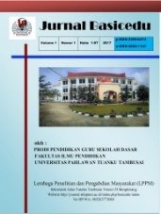
JURNALBASICEDU
Volume x Nomor xBulan xTahun x Halaman xx
Research &Learningin Elementary Education
https://jbasic.org/index.php/basicedu

THE EFFECT OF QUANTUM MODEL TO
STUDENTS’ LEARNING INDEPENDENCE FOR ELEMENTARY SCHOOL IN TEACHING NATURAL SCIENCE LEARNING

Sumiati Pulungan¹, Yanti Fitria²
Program Studi Pendidikan Dasar, Universitas Negeri Padang
sumiatipulungan@gmail.com, yantifitria@ymail.com

Abstrak
Penelitian ini bertujuan untuk menemukan pengaruh model pembelajaran quantum terhadap kemandirian belajar siswa sekolah dasar pada pelajaran IPA. Penelitian ini adalah penelitian tindakan kelas. Penelitian ini dilakukan di SDN 060827 Medan dengan subjek penelitiannya terdiri dari 37 siswa kelas V. Pengumpulan data dilakukan dengan observasi dan kuesioner. Data dianalisa dijelaskan dengan bebrapa langkah yaitu pengumpulan data, pengurangan data, penampilan data dan membuat kesimpulan. Hasil dari penelitian membuktikan bahwa ada pengaruh model pembelajaran quantum terhadap kemandirian belajar siswa untuk siswa sekolah dasar pada mata pelajaran IPA. Model Kuantum sangat efektif digunakan dalam pembelajaran IPA untuk anak sekolah dasar.
Kata Kunci: Model Quantum, Kemandirian Belajar Siswa, IPA

Abstract
The purpose of this reserach was to find out the effect of quantum model to students learning independence for elementary school in teaching natural science learning. The research design was classroom action research. This research was done at SDN 060827 Medan with the subject of the research was 37 students of grade V. The data collection was using: observation and questionnaire. The data was described and elaborated by mixing some steps, they were collecting the data data reduction, data display and finally conclusion. The result of the research prove that there was effect of quantum model to students’ learning independence for elementary school in teaching natural science learning. Among of indicators, the highest score was motivation. Quantum model is very effective to use in teaching natural science learning for elementary school

Keywords: Quantum Model, Students’s Learning Independent, Natural Science Learning

Copyright (c) 2021 Sumiati Pulungan¹, Yanti Fitria²
Corresponding author :
Email : sumipulungan@gmail.com ISSN 2580-3735 (Media Cetak)
HP : 081377008696 ISSN 2580-1147 (Media Online)

Received xx Bulan 2021, Accepted xx Bulan 2021, Published xx Bulan 2021

INTRODUCTION
Education is the most important aspect in preparing human resouces in digital era right now. It is very clear that a developing country can be seen by education. Education, especially natural science has a very important role to solve and overcome these recent problems. Sugiyono (2015:42) noted that national education has aim to develop the potential of students to become good human beings, have faith and fear of God Almighty, as well as skills that is needed by himself, the community, the nation and the state. So every school has to have big effort to improve their quality of teaching. The quality of the education process determines the results of education because if the process taught by the teacher well, the result got by the students will be good. Improving the quality of education can be done through improving the quality of learning which is determined by the teacher in teaching learning process in the classroom. Indicator for the success of the teaching learning process can also be determined by learning facilities and infrastructure, class conditions, learning methods, and also students’ learning independence in following the lessons given by the teachers.
Students’ learning independence comes from the students themselves which can be shown from the activeness and enthusiasm of students in following lessons in the class. If the students feel interested in learning, of course the lesson will be interesting. Yamin in Sudarwo (2018:69) stated that independent learning is an active learning method to develop each individual who is not tied to the presence of learners in a face-to-face class meeting or the presence of other study friends. Students who study independently will try by themselves to understand the essence of the activities they read or see (Ramahdani, 2021: 4102). Independent learning is a situation of learning activity independent, it does not depend on others and they take responsibility for themselves in solving a problem. By knowing definition of independent learning, it is concluded that the indicators of independent learning include: self-confidence, self-discipline, initiative, responsibility and motivation (Dharmawati, 2021: 1637). The importance of students’ learning independent can be seen from situations in teaching learning process that really need the attention from education world. Situations occur in the context of learning are students who almost don’t have independent in learning. That’s way students’ independence in learning is very important and needs to be developed in students. Students’ learning independence is also needed in natural science learning as one of important subject in elementary school.
Natural science learning is has an important role in improving the quality of education, especially to produce a generation that quality, namely humans who are able to think critical, creative, and logical (Fitria, 2017: 34). It consists of concept and abstract principles, so it is needed the ability to think creativity, solve problem and make a decision by having learning independent. In teaching natural science learning, the teachers need a learning model to improve students’ learning independence. This statement was also supported by Martha and friends (2020: 150), they said that in science learning, teachers are needed who are creative in choosing and determining learning models. The teacher also must have many ideas in making interesting teaching learning process. One of learning model can be used for the teacher is quantum model. In this model, there are steps in structuring the learning environment and giving motivation, so that an optimal learning environment can be created to achieve the learning objectives and the learning atmosphere becomes more comfortable and pleasant (Pratama, 2019: 397). Studying natural science is not only just understand the concept or just the procedure, but many things that can arise from the results of the process learning natural science.
Quantum model is one of the student-centered learning model. It puts students as a subject in teaching learning process (student-oriented). In this learning process, students became the center of teaching natural science learning. Sasmita (2018: 164) stated that quantum learning model is considered capable as an alternative to learning renewal, because it provides practical and specific instructions for creating an effective learning environment for how teachers design learning, delivering learning materials, and how to simplify the learning process so that it makes learning easier for students. Quantum model gives more effective and give good result because the basic principle in the quantum model is to create or make fun effective teaching learning process. Quantum model in teaching learning process also includes all related interactions to improve students’ learning independence students in natural science learning. The principles of the Quantum Teaching Learning model create the best learning environment for students (Kristianto, 2020: 180). A learning environment when theaching learning process happens, can bring to positive attitudes and thoughts. In learning activities for social science, teacher involves students actively in their learning process.
Based on the observation in October 2021 at grade V SDN 060827 showed that natural science learning as the subject school was carried out with teacher-centered approach, so students only listen to the lessons explained by the teacher. As the result, the students’ KKM (minimum completeness criteria) was still low. The average score of students were 65, meanwhile KKM from natural science learning was 70. From 36 students, there were 14 students which got score 70. And the rest students got below 70. It means that there were only 38% students could reach KKM in this school and the other 62kk% only got under 70. The low achievement in learning natural science of students was influenced by having independent learning in school. The teaching learning process can success not only from face-to-face activities and structured assignments given by teacher, but also in the independence in learning that students have. The problem found in the classroom when the teacher were teaching natural science learning. The problem was conventional method used by the teacher make the classroom boring. Theacher who taught Teaching natural science learning makes students became passive and the students didn’t have creativity in thinking. As the result, they will get low score. This low score will effect to their learning outcomes.
Based on the interview that had been done to the teacher, it was stated that the students’ learning learning was still low. The low students’ quality can affect the students’ achievement in learning. These low achievements are influenced by students’ learning independence. Most of the students wouldn’t read their books or do the exercises in if the teacher didn’t give instruction to them. When teaching learning process happened, students did not have the responsibility to learn by themselves. And there were some students playing and talking to with their classmates. They enjoyed when the teacher didn’t give them assignment, and they did nothing in the classroom. It seemed that they have motivation to study especially to study natural science learning. Students had not been given the opportunity to involve in understanding the concept of natural science learning, there were also still many students who did not understand the material they had just learned during the evaluation learning is carried out.
This situation was supported by the way the teacher give teaching material and learning method used can also affect students’ achievement in learning natural science. It was another fact, the results of natural science learning achieved in the fifth grade students of the elementary school in SDN 060827 so far was still not optimal. So, to solve this problem, the teacher was forced to choose the best method to improve students’ learning independence. And quantum model can be choice by the teacher in teaching natural science learning for students in grade V. Based on the background, the purpose of this reserach was to find out the effect of quantum model to students learning independence for elementary school in teaching natural science learning. Based on the theory, this reserach used four indicator of students’ learning independence, they are self-confidence, self-discipline, initiative, responsibility and motivation.

METHOD
The research design was classroom action research by using combination from quantitative and qualitative approach. Classroom action research is an implementation process which can help teachers to examine and investigate aspects of teaching learning process and take action to improve classroom activities. The subject of the research was 36 students in grade V of SDN 060827 Medan in teaching learning natural science for the subject of environmental from tematik book. The data collection was using: (1) Observation, it was used to observe students’ learning independent related to apply quantum model in teaching learning natural science, (2) Questionnaire, it was used to observe students’s independent learning. In Analysing the data, it was described by using numbers and presented by the table and figure. The data was described and elaborated by mixing some steps, they were collecting the data (it was taken by having observation, interviews and document), data reduction (it was done by selecting the data, focusing and making simplifying), then data display (it was presented in table and figure) and finally making conclusion (it was done by giving the meaning, confirming and verifying).
The scale range of achievement was taken from Riduwan (2010: 138) which explains the score interpretation criteria for having achievement level was presented in table 1.

Table 1 Scale Range of Achievement
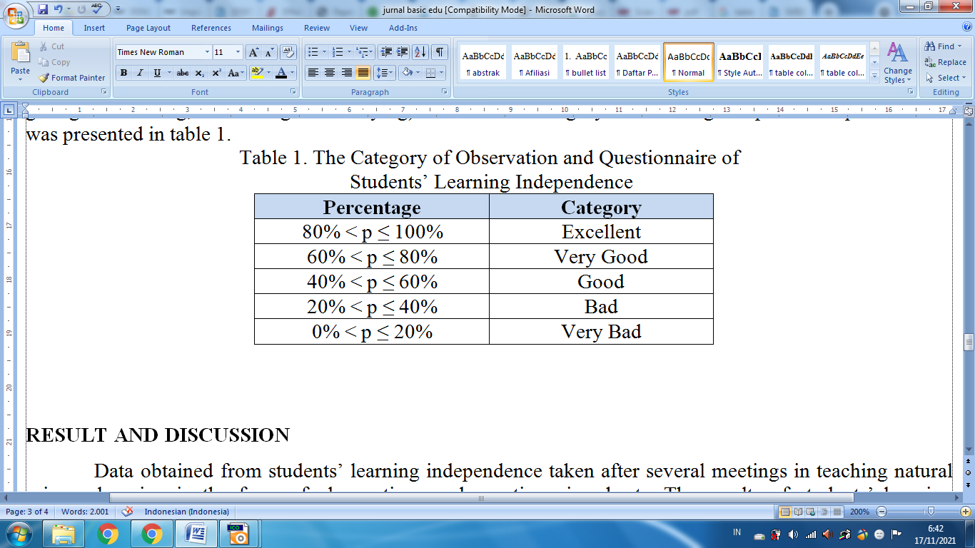

RESULT AND DISCUSSION
Data in Cycle 1
The analysis of students’ independence learning was also analyzed by using the indicators of independent learning, it consists of self-confidence, self-discipline, initiative, responsibility and motivation. The score was resulted from students’ independence learning questionnaire in learning natural science subject. The data was taken from the first and second meeting of cycle I, Data obtained from the observation sheet of students’ learning independence, it was known as the first cycle, the score an average of 92,5 with a percentage of 64,1% so it was included in good category of learning independence. The percentage of 64.1% had not reached as the successful indicator, so it must be improved. A questionnaire data of learning independence in cycle I, the learning independent score was 121,5 with the average score of 3,2 and the presentation of learning independence was 65.8%. It was included in good category.
Data observation of applying quantum model in teaching natural science learning was shown that students still was not motivated and felt unconfident in sharing ideas and giving opinion. There was also small discussion group related questions and answers but it seemed stuffy and boring. They felt afraid and shy to speak up. Based on the description if it was seen from success criteria, the learning independence of grade V SDN 060827 in the first cycle of meetings one and two could be concluded that learning independence had not been achieved because the indicator of success that students had to achieve was 80%.

Data in Cycle II
Students’ learning independence data was taken in the first and second meeting of cycle II, the instruments data were in the form of observation sheets and questionnaire sheets obtained an average score of 130.5 with the percentage of 85.5%, it was included in very good criteria of learning independence. So it can be concluded that there was an improving score from cycle I with an average score of 92.5 with a percentage of 64.1% to 130.5 and the average score with percentage of 85.5%. The results of the students' learning independence analysis were presented in a figure below:

Figure 1 The students' learning independence
Figure 1 shows that from cycle I and Cycle II, there was a very significant improvement percentage in students’ learning independence after students learned natural science learning by using quantum model. It moved from good criteria to very good criteria, it means that students had a successful indicator of learning.
The analysis of students’ independence learning was also analyzed based on the indicator of learning independence. The scores were resulted from students’ independence learning questionnaire in learning natural science and the result can be shown in table below.

Table 2. Indicator of Independent Learning
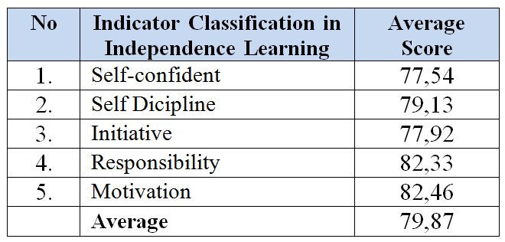

Table 2 described that the avarage score for self-confident was 77,54, self-discipline was 79,13. The avarage score for initiative was 77, 92, responsibility was 82,33 and motivation was 82,46. And the average score for indicator classification in independence learning is 79,87, it was included was very good. Among of indicators, the highest score was motivation. It means that students has good motivation learning natural science by using quantum model. Actually the result of this reseach where there was improvement in students’ learning independence, it can prove that there is effect of quantum model to students’ learning independence for elementary school in teaching natural science learning.
From the analysis of the data, the result of this research was the same with Jannah (2016), she mentioned that by using quantum model in teaching learning process, students’ learning independence could be improved. Quantum model can also improve students motivation as one indicator of learning independence. Wote and friends (2020) also supported this research result, they stated that the quantum model is very effective to use in teaching natural science learning for elementary school and it can improve the students learning outcomes. Because quantum model is a teaching model which can create interesting situation in learning natural science.

CONCLUSION
Based on the description from result and discussion of the research, it can be concluded that from cycle I and cycle II, it was obteined there was improvement from the score for students’ learning independent.The avarage score from indicator of learning independence such as self-confident was 77,54, self-discipline was 79,13, initiative was 77, 92, responsibility was 82,33 and motivation was 82,46. Among of indicators, the highest score was motivation . And the average score for indicator classification in independence learning is 79,87, it was included was very good and there was effect of quantum model to students’ learning independence for elementary school in teaching natural science learning. Quantum model is very effective to use in teaching natural science learning for elementary school.

REFERENCES
DePorter, B., & dkk. 2014. Quantum Teaching (Mempraktikkan Quantum Learning di ruang-ruang kelas). Penerbit Kaifa: Bandung.
Dharmawati Dharmawati. 2021. An Analysis of Students’ Learning Independence in Learning English for Computer Using Google Classroom. Budapest International Research and Critics Institute-Journal (BIRCI-Journal), Vol. 4, No. 2, pp. 1635-1642.
Fitria Yanti. 2017. Efektivitas Capaian Kompetensi Belajar Siswa Dalam Pembelajaran Sains Di Sekolah Dasar. Jurnal Inovasi Pendidikan Dan Pembelajaran Sekolah, Volume 1, Nomor2, hal. 34-42.
Jannah N.F. 2016. Peningkatan Kemandirian Belajar Siswa Dengan Model Pembelajaran Quantum Teaching. Jurnal Equivalen: Jurnal Pendidikan Matematika, Vol. 21, No. 1, hal 77-82.
Marta H, Fitria Y, Hadiyanto H, Zikri A. 2020. Penerapan Pendekatan Contextual Teaching And Learning Pada Pembelajaran Ipa Untuk Meningkatkan Hasil Belajar Dan Motivasi Belajar Siswa Sekolah Dasar. Jurnal Basicedu: Journal of Elementary Education, Vol. 4, No. 1, hal. 149-157
Kristiyanto, W., Gunarhadi, & Indriayu, M. 2020.The effect of the Science Technology Society and the Quantum Teaching Models on learning outcomes of students in the natural science course in relation with their critical thinking skills. International Online Journal of Education and Teaching (IOJET), 7(1). 177- 191
Pratama Adi. Y, M. Solehuddin. 2018. Effect of Quantum Learning Model on Higher Order Thinking Skills in Grade 4th Elementary School. Proceedings of the 3rd Asian Education Symposium (AES 2018), Atlantis Press, pp. 396-400.
Sasmita, Amara and Khusnul Fajriyah. 2018. Pengembangan Modul Berbasis Quantum Learning Tema Ekosistem Untuk Kelas V Sekolah Dasar. Jurnal Refleksi Edukatika, 8 (2) 163- 170
Sugiyono. 2015. Metode Penelitian Kombinasi (Mix Methods). Bandung: Alfabeta.
Vivi L, Yanti F, Yalvema M, Ahmad Z. 2020. Pembelajaran Ipa Dengan Strategi Pembelajaran Inkuiri Untuk Meningkatkan Keterampilan Proses Sains Dan Motivasi Belajar Siswa Di Sekolah Dasar. Jurnal Basicedu: Journal of Elementary Education, Vol. 4, No. 1, hal. 168-174.
Whasti Ramadhani, Fitria Y. 2021. Capaian Kemandirian Belajar Siswa dalam Pembelajaran Sains Tematik menggunakan Modul Digital. Jurnal Basicedu: Journal of Elementary Education, Vol. 5, No. 5, hal. 4101-4108
Wote Alice Y, MardinceSasingan, OkvinElselrisKitong. 2020. Efektivitas Penggunaan Model Quantum Teaching dalam Meningkatkan Hasil Belajar IPA. Journal of Education Technology. Vol. 4(2) pp. 96-102.

